Replacement doors |  | Heavy duty tee hinges |  | Hook and Band Hinges |  | Heavy Reversible Cup Hinges
 |  | 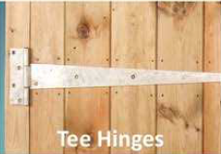 |  | 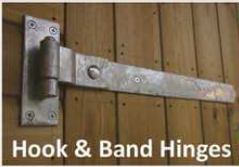 |  | 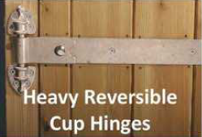
Door Size | Hinge Size Frame
(frame not included)

Complete Stable Doors
1.10 x 2.10m | 24” £80.00 | £280.00 |  | £300.00 |  | £340.00
1.22 x 2.10m | 24” £80.00 | £280.00 |  | £300.00 |  | £340.00
Bottom Stable doors
1.10 x 1.20m | 24” £80.00 | £160.00 |  | £180.00 |  | £200.00
1.22 x 1.20m | 24” £80.00 | £160.00 |  | £180.00 |  | £200.00
Garage/ Barn Doors
1.80 x 2.10m | 24” £120.00 | £250.00 |  | £270.00 |  | £290.00
2.10 x 2.10m | 24” £120.00 | £300.00 |  | £320.00 |  | £340.00
2.40 x 2.10m | 24” £120.00 | £300.00 |  | £320.00 |  | £340.00
2.70 x 2.10m | 24” £120.00 | £300.00 |  | £320.00 |  | £340.00
Tack Room Doors
0.81 x 2.10m | 24” £80.00 | £140.00 |  | £160.00 |  | £180.00
0.90 x 2.10m | 24” £80.00 | £140.00 |  | £160.00 |  | £180.00
1.20 x 2.10m | 24” £80.00 | £180.00 |  | N/A
Top Back doors
1.00 x 0.8m | 16” | £180.00 |  | £200.00 |  | £220.00
Top Stable doors | 24’’ | £130.00 |  | £150.00 |  | £160.00
.
All Prices Subject To VAT
2.4m Sliding door £900.00

Framed, ledged and braced (FLB) door POA

Available with or without threshold, and includes door frame and 5 lever mortice lock:
Casement doors.
Are available in many sizes, with various options available for glazing. All are priced on application.
Windows
Hunter window. Fixed acrylic pane with fixed louvered vents. |  | 0.6 x 0.9m | £120.00
Heavy duty window grill. (to fit hunter window) |  | ---
Casement windows. Glazed in 6.4mm laminated glass |  | 1.2 x 1.05m
 |  | 0.9 x 1.05m
 |  | 0.625 x 0.9m
Double glazing for casement windows |  | --- | P.O.A

